**FULL TITLE BOLD, CENTRE, 12 PT, TIMES NEW ROMAN**

**Author Title, Name and SURNAME**

University Name, E-Mail Address - ORCID NO

**Author Title, Name and SURNAME**

University Name, E-Mail Address - ORCID NO

**Abstract**

The text should be justified, Times New Roman, 12 font size. References will not be cited in the abstracts. Please send it in Word (.doc or .docx) file in accordance with the specified format conditions. Studies sent in pdf format will not be evaluated. Line spacing should be 1.5 spaces. Margins should be 2,5 cm on all sides. Figures, tables, pictures should not be included in the abstract. All studies are checked for plagiarism. If the plagiarism rate exceeds 20% in full texts, the work will be returned. Please check your work before submission. E-mail addresses of other authors should be included in the colophon of the study. Footnotes should be in 10 pt. Studies divided into columns are not accepted. A 6 nk. space should be set for before and after paragraphs. Abstract should be written in a minimum of 150 and maximum 250 words.

**Keywords:** At least 3 keywords must be written.

## 1. Introductin

## 2. Theoretical Framework

## 3. Methodology

## 4. Findings

## 5. Conclusion and Discussion

## References

## 1. Journal article with Doi Number

Grady, J. S., Her, M., Moreno, G., Perez, C., & Yelinek, J. (2019). Emotions in storybooks: A comparison of storybooks that represent ethnic and racial groups in the United States. Psychology of Popular Media Culture, 8(3), 207–217. <https://doi.org/10.1037/ppm0000185>

## 2. Journal Article without Doi Number

Asar, R. ve Çelikten, Y. (2016). Shadowing a woman administrator: A Turkish case. Universal Journal of Management, 4(11), 607-614.

## 3. Popular Journal Article

Özbaşaran-Dede, N. (2008, Kasım). Küresel iklim savaşçıları: Solucanlar. Bi­lim ve Teknik, 492, 11-13.

## 4. Single-authored book

Balcı, A. (2005). Açıklamalı eğitim yönetimi terimleri sözlüğü. Tek Ağaç.

## 5. Multi-authored book

Başaran, İ. E. ve Çınkır, Ş. (2011). Türk eğitim sistemi ve okul yönetimi. Ekinoks Yayınevi.

## 6. Edited book

Kesharwani, P. (Ed.). (2020). Nanotechnology based approaches for tuberculosis treatment. Academic Press.

## 7. Chapter in edited book

Dönmez, B. (2013). Motivasyon. S. Özdemir (Ed.), Eğitim yönetiminde kuram ve uygulama içinde (s. 185-229). Pegem Akademi.

## 8. Encyclopaedia or Dictionary

Sadie, S. (Ed.). (1980). The new Grove dictionary of music and musicians (6th ed., Vols. 1-20). MacMillan.

## 9. Newspaper

Hitts, P. J. (16 Şubat 1999. In forecasting their emotions, most people flunk out. New York Times. [http://www.nytimes.com](https://www.nytimes.com/)

## 10. Conference proceedings

Karadağ, E. ve Öney, A. (2006, Eylül). Okul yöneticilerinin stres düzeyleri­nin öğretmenlerinin stres düzeylerine etkisinin incelenmesi. 14. Ulusal Psikoloji Kongresi’nde sunulan bildiri. Hacettepe Üniversitesi Psikoloji Bölümü, Ankara.

**Rules:**

**-** All papers (Turkish and English) should be written in accordance with these spelling rules.

- Similar uses such as photographs, pictures, visuals should be indicated as "Figure".

- Descriptions of Tables and Figures should be written in 11 pt.

- Table titles should be written above the table and figure titles should be written below the figures.

- English abstract and English title should be included in Turkish studies.

- Sample table and figure representations are shared below;

1. Table Title should be written on the Table

|  |  |
| --- | --- |
| Xxxxxxxx | Xxxxxxx |
| Xxxxxxx | Xxxxxxxx |

**Source:** (ICOFESP, 2024)

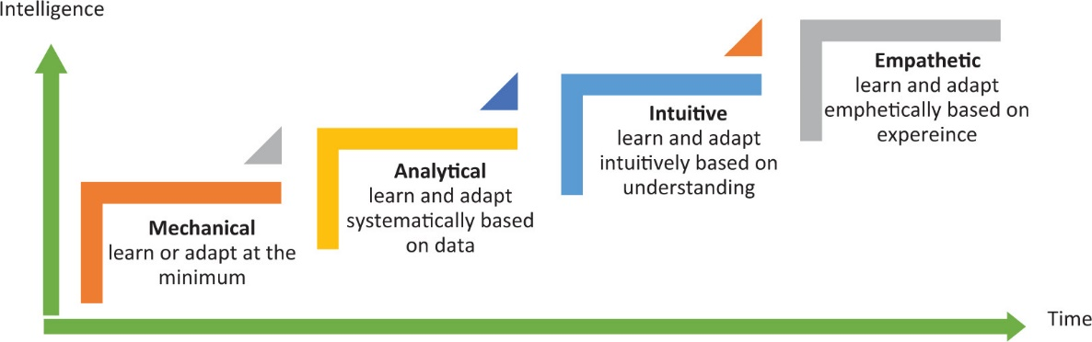

**Figure 1. Figure titles should be written below the figure (Kaynak, 1999).**

- All text should be written with 1.5 line spacing, 12 font size and Times New Roman character.

- Photographs to be used in the paper should be in JPEG format (300dpi).

- 1st degree headings should be written in Times New Roman, Bold, 12 pt., and all letters should be capatalised.

- 2.3.4. degree titles should be written in Times New Roman, Bold, 12 Punto and only the first letters of the words should be capitalised.